**BLOOD & ORGAN DONATION SYSTEM**

**ABSTRACT**

**TITLE OF PROJECT: BLOOD & ORGAN DONATION SYSTEM**

**Introduction:**

This System is a web application developed for blood donation. Doctors can register in website and can register patients details who are in a need for blood through this site. Also donors can register here who are willing to donate their blood and organs.

**Project Analysis:**

This application consists of following modules:

Administrator

Doctors

Donors

**Module I: Administrator**

Add, View and manage the details of the doctors,patients and donors.When blood is needed for a patient,then he sends an alert message to donor for blood.Admin also maintains the details of organ donors separately.

**Module II: Doctors**

Registered doctor have his or her own profile.

They can login and then register the list of patients.They can also view donors details.

**Module III: Donors**

Blood donors can register in the site and provide the available days of donating,blood group etc.They can even donate their organs if they are interested.

(v)

TABLE OF CONTENT

Pg No.

1. INTRODUCTIOn 1

2. Software and Hardware requirements 3

3. Review of Literature 4

4. Software Requirement Analysis 11

4.1 PROBLEM DEFINITION

4.2 modules funtionality

5. Software Design 13

5.1 UML DIAGRAMS

6. CODING 19

6.1 DATABASE TABLES

7. TESTING 31

8. OUTPUT SCREENS 36

9. BIBLIOGRAPHY 49

(vi)

**1. INTRODUCTION:**

Blood and Organ Donation System is a java based web application which shows and helps you to collect most of the information about blood donation. Doctors can register in website and can submit patients details who are in a need for blood through this application. Also donors can register here who are willing to donate their blood. This application will help you to find the blood donors as well as organ donors. There is a separate login for different type of users.

If a patient is in need of blood, then a doctor submits the details of that patient in the application. Admin views the details of patients and tries to find out the donors matching patient’s blood group. If respective blood group is found in donors list, then admin sends that particular donor a alert message requesting for blood and also mentioning place, time etc.

**EXISTING SYSTEM:**

It is a manual process. Doctors have to make query through the telephonic media or consulting the hospitals directly. One man should be there to search for the person willing to donate blood. Existing system is having the following disadvantages

* It is very difficult to keep the track of data.
* It is difficult to update the data.
* It is time consuming process.
* Difficult to search for donors.
* Data may not be available when we require.

**PROPOSED SYSTEM:**

Here, everything is online, doctors can search for the donor through this system . There won’t be any delay. It doesn’t require any person to work manually. It needs only an administrator.

1

Proposed system is having the following advantages

* It is easy to keep the track of data.
* It is easy to update the data.
* It will take less time.
* Easy to search for donors.
* Data is available when we require.

This system consists of three modules, they are:

1) Administrator

2) Donors

3) Doctors

Each module in this application has its own functionality. The Functionalities of all the three modules are clearly explained in below section.

There’s only one administrator in this system. There can be multiple number of donors and doctors using this application.

2

**2. SYSTEM REQUIREMENTS:**

## 

## SOFTWARE REQUIREMENTS:

Operating System : Windows 7

Technologies : Java/J2EE (JSP, Servlets , JDBC)

Web Technologies : HTML, JavaScript, CSS.

Web Server : Tomcat 7.0

Database : Oracle 10g Express Edition.

Software : JDK 1.6

3

**3. REVIEW OF LITERATURE:**

**LANGUAGES USED:**

In this project, I have used Java technologies such as JSP(Java Server Pages), JDBC(Java Database Connectivity). I have also used HTML, CSS and Oracle RDBMS(Relation Database Management System) for my project.

**JAVA SERVER PAGES:**

Java server pages is a simple but powerful technology used to generate dynamic web pages on the server side. JSP’s are direct extension of java servlets and provide a way to separate content generation from content presentation.

**FEATURES OF JSP:**

* Portability

Java Server Pages files can be run on any web server or web-enabled application server that provides support for them. Dubbed the JSP engine, this support involves recognition, translation and management of the Java Server Page lifecycle and its interaction components.

* Components

It was mentioned that the Java Server Pages architecture can include reusable Java components. The architecture also allows for the embedding of a scripting language directly into the Java Server Pages file. The components current supported include Java Beans and Servlets.

* Processing

A Java Server Pages file is essentially an HTML document with JSP scripting or tags. The Java Server Pages file has extension to the server as a Java Server Pages file. Before the page is served, the Java Server Pages syntax is parsed and processed into a Servlet on the server side. The Servlet that is generated outputs real content in straight HTML for responding to the client.

4

**HTML:**

HTML, which stands for Hypertext Markup Language, is the predominant markup language for web pages. It provides a means to create structured documents by denoting structural semantics for text such as headings, paragraphs, lists, links, quotes and other items. It allows images and object to be embedded and can be used to create interactive forms. It is written in the form of HTML elements consisting of “tags” surrounded by angle brackets within the web page content. It can embed scripts in languages such as JavaScript which affect the behavior of HTML web pages. HTML can also be used to include Cascading Style Sheets (CSS) to define the appearance and layout of text and other material. The W3C, maintainer of both HTML and CSS standards, encourages the use of CSS over explicit presentational markup.

**Basic HTML Tags:**

<!-- --> Specifies comments

<A>………</A> Creates hypertext links

<B>……….</B> Formats text as bold

<BIG>…….</BIG> Formats text in large font

<BODY>……</BODY> Contains all tags and text in the HTML documents

<CENTER>…….</CENTER> Aligns text center

<DD>………….</DD> Definition of a term

<DL>…………..</DL> Creates definition list

<FORM>……….</FORM> Encloses a fill-out form

<FRAME>……….</FRAME> Defines a particular frame in a set of frames

<HEAD>………</HEAD> Contains tags that specify information about a document

<HR>…………</HR> Creates a horizontal rule

<HTML>………</HTML> Contains all other HTML tags

<META>……..</META> Provides meta-information about a document

5

<SCRIPT>………</SCRIPT> Contains client-side or server-side script

<TABLE>………</TABLE> Creates a table

<TR>………</TR> Designates a table row

<TH>………</TH> Creates a heading in a table

**Advantages:**

* A HTML document is small and hence easy to send over the net.It is small because it does not include formatted information.
* HTML is platform independent.
* HTML tags are not case-sensitive.

6

**JDBC:**

JDBC is an API for the java programming language that defines how a client may access a database. It provides methods for querying and updating data in a database. JDBC is oriented towards relational databases.

JDBC was first introduced in the Java2 Platform, Standard Edition, version 1.1(J2SE), together with a reference implementation JDBC-to-ODBC bridge, enabling connections to any ODBC-accessible data source in the JVM host environment.

**Functionality:**

JDBC allows multiple implementations to exist and be used by the same application. The API provides a mechanism for dynamically loading the correct java packages and registering them with the JDBC Driver Manager. The Driver Manager is used as a connection factory for creating JDBC connections.

JDBC connections support creating an executing statements. These may be update statements such as SQL’s CREATE, INSERT, UPDATE and DELETE or they may be query statements such as SELECT. Additionally, stored procedures may be invoked through a JDBC connection.

JDBC represents statements using one of the following classes:

* Statement – the statement is sent to the database server each and every time.
* Prepared Statement- the statement is cached and then the execution path is pre determined on the database sever allowing it to be executed multiple times in an efficient manner.
* Callable Statement-used for executing stored procedures on the database.

Update statements such as INSERT, UPDATE and DELETE return an update count that indicates how many rows were affected in the database. These statements do not return any other information.

7

Query statements return a JDBC row result set.The row result set is used to walk over the result set. Individual columns in a row are retrieved either by name or by column number. There may be any number of rows in the result set. The row result set has metadata that describes the names of the columns and their types.

**JDBC Drivers:**

JDBC drivers are client-side adapters (installed on the client machine, not on the server) that convert requests from java programs to a protocol that the DBMS can understand.

JDBC drivers fall under four categories:

* TYPE-1
* TYPE-2
* TYPE-3
* TYPE-4

Type 4 driver has been used in this project.

**STAGES IN A JDBC PROGRAM:**

1. REGISTERING THE DRIVER:

A database driver is software containing the classes and interfaces written according to the JDBC API. Since there are several drivers available in the market, we should first declare the driver which is going to be used for communication with the database server in a java program.

1. CONNECTING TO A DATABASE:

In this stage we establish the connection with a specific database through the driver which is already registered in the previous step.

8

1. PREPARING SQL STATEMENT:

We should create SQL statements in our java program using any one of the interfaces like Statement, Prepared Statement, Callable Statement which are available in java.sql package.

1. EXECUTING THE SQL STATEMENTS ON THE DATABASE:

For this purpose,we can use executeUpdate(), executeQuery(), methods of statement Interface.

1. RETRIEVING THE RESULTS:

The Results obtained by executing the SQL statements can be stored in an object with the help of interfaces like Result Set.

1. CLOSING THE CONNECTION:

We should close the connection between the Java program and the database using close() method of connection Interface.

9

**DATABASE:**

A database is a separate application that stores a collection of data. Each database has one or more distinct APIs for creating, accessing, managing, searching and replicating the data it holds.

Other kinds of data stores can be used, such as files on the file system or large hash tables in memory but data fetching and writing would not be so fast and easy with those type of systems.

The Oracle Database (commonly referred to as Oracle RDBMS or simply as Oracle)is an object-relational database management system produced and marketed by Oracle Database.

**DBMS Terminology:**

Database: A database is a collection of tables, with related data.

Table: A table is a matrix with data. A table in a database looks like a simple spreadsheet.

Column: One column (data element) contains data of one and the same kind, for example the column postcode.

Row: A row (tuple, entry or record) is a group of related data, for example the data of one subscription.

Primary Key: A primary key is unique. A key value cannot occur twice in one table. With a key you can find at most one row.

Foreign Key: A foreign key is the linking pin between two tables.

**Composite Key:** A composite key is a key that consist of multiple columns,

because one column is not sufficiently unique.

10

**4. SOFTWARE REQUIREMENT ANALYSIS:**

# PROBLEM DEFINITION:

As we currently use to make search for blood through telephonic media or may consulting the hospitals directly. This is having the following disadvantages

It is very difficult to keep the track of data.

It is difficult to update the data.

It is time consuming process.

Difficult to search for donors.

Data may not be available when we require.

**MODULES AND THEIR FUNCTIONALITIES:**

This application consists of three modules, they are:

1) Administrator

2) Donors

3) Doctors

Each module in this application has its own functionality. The Functionalities of all the three modules are clearly explained in below.

**ADMINISTRATOR:**

He is treated as a owner of the web site.

The main aim of an Administrator is updating the status of the donors who has registered in the website. Administrator has to check the data about patients. He has to manage the data about doctors and patients. They accept the doctors registrations. He will also maintain the details of organ donors.

The main task of admin is Add, View and manage the details of the doctors, patients and donors.

He also sends an alert message to donor for blood.

11

**DOCTORS:**

Doctors have to get registered into the website. Registered doctor have his or her own profile.

They have to login into the site for carrying out their tasks.

They can register the patient details who are in need of blood. They can delete the patients after the treatment.

Doctors can view donor details.

**DONORS:**

Donor has to register into the website to access this application by providing appropriate details.

Admin will verify the details of Donors and accepts the donors. Admin sends an alert message to them if in need of blood.

They can even register themselves as a organ donor after logging in. Organ donation is possible after his/her death, their family members will be informing so that doctors can collect his/her organs.

He/she can also update his/her own profile.

12

# 5. SYSTEM DESIGN:

## 5.1 UML DIAGRAMS:

A diagram is a graphical presentation of a set of elements, most often rendered as a connected graph. UML includes nine such diagrams. Unified Modeling Language (UML) is probably the most widely known and used notation for object-oriented methods. The Unified Modeling Language (UML) is a standard language for writing software blueprints.

The UML may be used to visualize, specify, construct and document the artifacts. A Modeling Language is a language whose vocabulary and rules focus on the conceptual and the physical representation of a system. Modeling is the designing of the software applications before coding. It is an essential part of large software projects, and helpful to medium and even small projects as well. A model plays an analogous role in software development project’s success can assure themselves that business functionality is complete and correct.

Care should be taken that end-user’s needs are met.

The underlying premise of UML is that no one diagram can capture the different elements of a system at different points often in the software life cycle of a system.

The UML diagrams are as follows:

13

**CLASS DIAGRAM:**

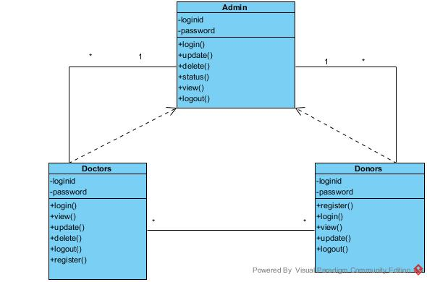

14

**USE CASE DIAGRAM:**

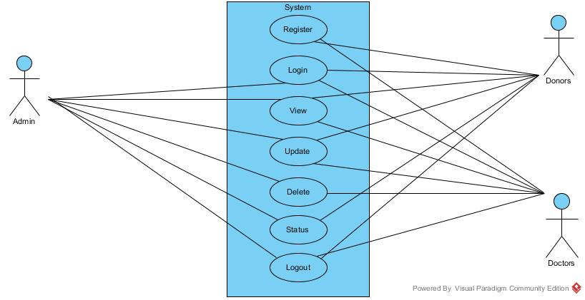

15

**ACTIVITY DIAGRAM:**

There are three different activity diagrams in this system.

Each module has a separate activity diagram.

**Activity Diagram for Administrator:**

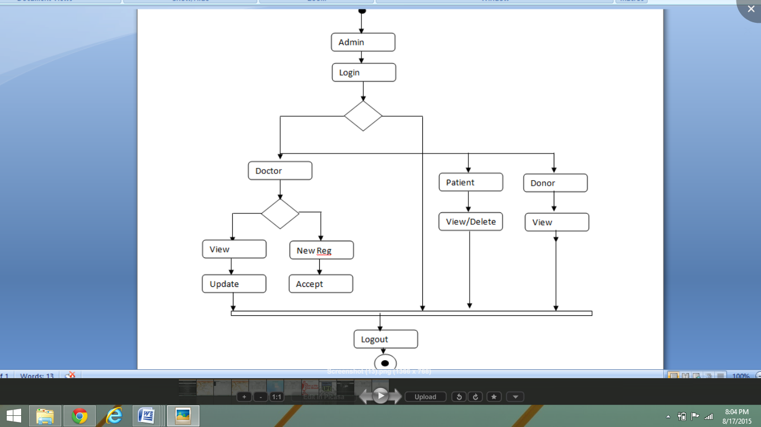

16

**Activity Diagram for Doctor:**

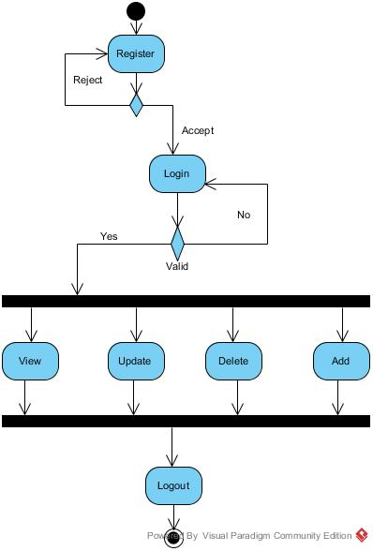

17

**Activity Diagram for Donor:**

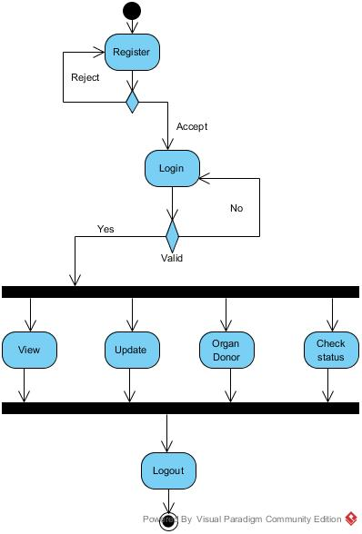

18

**6. CODING:**

This web application consists of several pages developed using JSP,JDBC,HTML,CSS etc. So, the code for few JSP pages are shown below:

**Index.jsp:-**

<%--

Document : index

Author : Pavan Kumar

--%>

<!DOCTYPE HTML PUBLIC "-//W3C//DTD HTML 4.01 Transitional//EN" "http://www.w3.org/TR/html4/loose.dtd">

<html xmlns="http://www.w3.org/1999/xhtml" dir="ltr">

<head>

<meta http-equiv="content-type" content="text/html; charset=utf-8" />

<title>Main</title>

<!-- Start css3menu.com HEAD section -->

<link rel="stylesheet" href="Home_files/css3menu1/style.css" type="text/css" /><style type="text/css">._css3m{display:none}</style>

<!-- End css3menu.com HEAD section -->

</head>

<body style="background-color:#EBEBEB" >

<body background="Images/2.jpg">

<center><h1 style="color:#FFF">Blood and Organ Donation System</h1><br>

<!-- Start css3menu.com BODY section -->

<ul id="css3menu1" class="topmenu">

<input type="checkbox" id="css3menu-switcher" class="switchbox"><label onclick="" class="switch" for="css3menu-switcher"></label> <li class="topfirst"><a href="home.jsp" style="height:32px;line-height:32px;">Home</a></li>

<li class="topmenu"><a href="#" style="height:32px;line-height:32px;"><span>Login</span></a>

<ul>

<li><a href="adminlogin.jsp">Admin</a></li>

<li><a href="donorlogin.jsp">Donor</a></li>

<li><a href="doctorlogin.jsp">Doctor</a></li>

</ul></li>

<li class="toplast"><a href="#" style="height:32px;line-height:32px;"><span>Donors</span></a>

<ul>

<li><a href="donorregis.jsp">Register</a></li>

<li><a href="checkstatus.jsp">Check Status</a></li>

</ul></li>

19

</ul><p class="_css3m"><a href="http://css3menu.com/">dropdown menu</a> by Css3Menu.com</p>

<!-- End css3menu.com BODY section -->

</body>

</html>

**Doctorlogin.jsp:-**

<%--

Document : doctorlogin

Author : Pavan Kumar

--%>

<%@page contentType="text/html" pageEncoding="UTF-8"%>

<%@include file="index.jsp" %>

<!DOCTYPE html>

<html>

<head>

<meta http-equiv="Content-Type" content="text/html; charset=UTF-8">

<title>Doctor login</title>

<style>

h6{color:red}

</style>

</head>

<body>

<center><h1 style="color:whitesmoke">Doctor login</h1>

<form action="doctorlogin_act.jsp" method="post">

<table align="center" cellspacing="5" cellpadding="2">

<tr>

<td style="color:whitesmoke">

UserId:

</td>

<td>

<input type="text" name="id"/>

</td>

</tr>

<tr>

<td style="color:whitesmoke">

Password:

</td>

<td>

<input type="password" name="pwd" />

</td></tr>

20

<tr>

<td>

<input type="submit" value="Login" />

</td>

<td>

<input type="reset" value="Cancel" />

</td>

</tr>

</table>

</form>

<br>

<a href="doctregis.jsp"><h4 style="color:white">New User?Register Now!</h4></a>

</body>

</html>

**Doctorlogin_action.jsp**:-

<%--

Document : doctorlogin_act

Author : Pavan Kumar

--%>

<%@page contentType="text/html" pageEncoding="UTF-8"%>

<%@include file="connect.jsp"%>

<!DOCTYPE html>

<html>

<head>

<meta http-equiv="Content-Type" content="text/html; charset=UTF-8">

<title>JSP Page</title>

<script type="text/javascript">

window.history.forward();

function noBack()

{

window.history.forward();

}

</script>

</head>

<body onload="noBack();" onpageshow="if(event.persisted)noBack();"onunload="">

<%

String n1=request.getParameter("id");

session.setAttribute("id",n1);

String n2=request.getParameter("pwd");

Statement st=con.createStatement();

21

ResultSet rs=st.executeQuery("select PASSWORD from DOCTORINFO where did='"+n1+"'");

if(rs.next())

{

String dpwd=rs.getString(1);

if(n2.equals(dpwd))

{

%>

<jsp:forward page="Docthome.jsp"></jsp:forward>

<%

}

else

{

out.println("<h1>enter valid password</h1>" );

}

}

else

{

out.println("<h1>enter a valid id</h1>");

}

%>

<a href="doctorlogin.jsp">Back</a>

</body>

</html>

**Donorregistration.jsp:-**

<%--

Document : donorregis

Author : Pavan Kumar

--%>

<%@page contentType="text/html" pageEncoding="UTF-8"%>

<!DOCTYPE html>

<html>

<head>

<meta http-equiv="Content-Type" content="text/html; charset=UTF-8">

<title>Donor Registration</title>

</head>

<body background="Images/blood.jpg">

<h1 align="center">Donor Registration</h1>

<form action="donorregis_act.jsp" method="post" name="f1">

<table align="left" cellspacing="5" cellpadding="2">

22

<tr>

<td>Id:</td>

<td><input type="text" name="id" value="" required=""/>

</td>

</tr>

<tr><td>

Password:</td>

<td><input type="password" name="pwd" value="" required=""/>

</td></tr>

<tr><td>

Name:</td>

<td><input type="text" name="name" value="" required="" />

</td></tr>

<tr><td>

Phone number:</td>

<td><input type="text" name="phno" value="" required="" />

</td></tr>

<tr>

<td>Gender:</td><td><input type="radio" name="gen" value="Male" />Male&nbsp;

<input type="radio" name="gen" value="Female" />Female</td>

</tr>

<tr><td>

Blood group:

</td><td><select name="bloodgrp" required="">

<option>A +ve</option>

<option>A -ve</option>

<option>B +ve</option>

<option>B -ve</option>

<option>AB +ve</option>

<option>AB -ve</option>

<option>O +ve</option>

<option>O -ve</option>

</select>

</td> </tr>

<tr><td>

Age:</td>

<td><input type="text" name="age" value="" required=""/>

</td></tr>

<tr><td>

Available Days:</td>

<td><input type="checkbox" name="availday" value="Sun" />Sun

<input type="checkbox" name="availday" value="Mon" />Mon

<input type="checkbox" name="availday" value="Tues" />Tues

<input type="checkbox" name="availday" value="Wed" />Wed

<input type="checkbox" name="availday" value="Thurs" />Thurs

23

<input type="checkbox" name="availday" value="Fri" />Fri

<input type="checkbox" name="availday" value="Sat" />Sat

</td></tr>

<tr><td>

Address:</td>

<td><textarea name="addrss" rows="4" cols="20" required="">

</textarea></td></tr>

<tr><td>

<input type="submit" value="Submit">&nbsp;</td>

<td><input type="reset" value="Reset" /></td>

</tr>

</table>

</form>

</body>

</html>

**Donorregistration_action.jsp:-**

<%--

Document : donorregis_act

Author : Pavan Kumar

--%>

<%@page contentType="text/html" pageEncoding="UTF-8"%>

<%@include file="connect.jsp" %>

<!DOCTYPE html>

<html>

<head>

<meta http-equiv="Content-Type" content="text/html; charset=UTF-8">

<title>JSP Page</title>

</head>

<body>

<%

String regid=request.getParameter("id");

String pwd=request.getParameter("pwd");

String name=request.getParameter("name");

String phno=request.getParameter("phno");

String gender=request.getParameter("gen");

String bldgrp=request.getParameter("bloodgrp");

String age=request.getParameter("age");

String avail="";

String days[]=request.getParameterValues("availday");

for(int i=0;i<days.length;i++)

{

24

avail+=days[i]+",";

}

String add=request.getParameter("addrss");

PreparedStatement ps=con.prepareStatement("insert into DONORREG values(?,?,?,?,?,?,?,?,?)");

ps.setString(1,regid);

ps.setString(2,pwd);

ps.setString(3,name);

ps.setString(4,phno);

ps.setString(5,bldgrp);

ps.setString(6,avail);

ps.setString(7,add);

ps.setString(8,age);

ps.setString(9,gender);

int k=ps.executeUpdate();

if(k!=0)

{

out.println("<h1>Registered Sucessfully</h1>");

}

else

{

out.println("Please enter all the fields ");

}

%>

<br><a href="donorlogin.jsp">Login</a>

</body>

</html>

**AdminHome.jsp:-**

<%--

Document : newjsp

Author : Pavan Kumar

--%>

<!DOCTYPE HTML PUBLIC "-//W3C//DTD HTML 4.01 Transitional//EN" "http://www.w3.org/TR/html4/loose.dtd">

<html xmlns="http://www.w3.org/1999/xhtml" dir="ltr">

<head>

<meta http-equiv="content-type" content="text/html; charset=utf-8" />

<title>Admin Home</title>

<!-- Start css3menu.com HEAD section -->

<link rel="stylesheet" href="AdHome_files/css3menu1/style.css" type="text/css" /><style type="text/css">._css3m{display:none}</style>

25

<!-- End css3menu.com HEAD section -->

<script type="text/javascript">

//window.history.forward();

function noBack(){

window.history.forward();}

</script>

</head>

<body style="background-color:#EBEBEB" background="Images/10.jpg" onload="noBack();" onpageshow="if(event.persisted)noBack();"onunload="">

<!-- Start css3menu.com BODY section -->

<ul id="css3menu1" class="topmenu">

<input type="checkbox" id="css3menu-switcher" class="switchbox"><label onclick="" class="switch" for="css3menu-switcher"></label> <li class="topfirst"><a href="Adminhome.jsp" style="height:25px;line-height:25px;">Home</a></li>

<li class="topmenu"><a href="#" style="height:25px;line-height:25px;"><span>Donors</span></a>

<ul>

<li><a href="adview.jsp">View</a></li>

<li><a href="addel.jsp">Delete</a></li>

<li><a href="adgenst.jsp">Generate Status</a></li>

<li><a href="organdonor.jsp">Organ Donors</a></li>

<li><a href="http://site23.way2sms.com/content/">Inform</a></li>

</ul></li>

<li class="topmenu"><a href="#" style="height:25px;line-height:25px;"><span>Doctors</span></a>

<ul>

<li><a href="adocview.jsp">View</a></li>

<li><a href="adocadd.jsp">Add</a></li>

<li><a href="adocdel.jsp">Delete</a></li>

</ul></li>

<li class="topmenu"><a href="#" style="height:25px;line-height:25px;"><span>Patient</span></a>

<ul>

<li><a href="apatview.jsp">View</a></li>

<li><a href="apatadd.jsp">Add</a></li>

</ul></li>

<li class="toplast"><a href="adlogout.jsp" style="height:25px;line-height:25px;">Logout</a></li>

</ul><p class="_css3m"><a href="http://css3menu.com/">dropdown menu</a> by Css3Menu.com</p>

<!-- End css3menu.com BODY section -->

<center><h1>Welcome Admin</h1>

</body>

</html>

26

**Adminviewingdonors.jsp:-**

<%--

Document : newjsp

Author : Pavan Kumar

--%>

<%@page contentType="text/html" pageEncoding="UTF-8"%>

<%@include file="connect.jsp" %>

<%@include file="Adminhome.jsp" %>

<!DOCTYPE html>

<html>

<head>

<meta http-equiv="Content-Type" content="text/html; charset=UTF-8">

<title>JSP Page</title>

</head>

<body>

<center><h1>List of Donors</h1>

<table border="1" cellspacing="5" cellpadding="5" width="100%">

<thead>

<th>Id</th>

<th>Password</th>

<th>Name</th>

<th>Phone number</th>

<th>Blood group</th>

<th>Avaliable Days</th>

<th>Address</th>

<th>Age</th>

<th>Gender</th>

</thead>

<%

Statement s=con.createStatement();

ResultSet rs=s.executeQuery("select *from DONORREG");

while(rs.next())

{

%>

<tr>

<td><%=rs.getString(1)%></td>

<td><%=rs.getString(2)%></td>

<td><%=rs.getString(3)%></td>

<td><%=rs.getString(4)%></td>

<td><%=rs.getString(5)%></td>

27

<td><%=rs.getString(6)%></td>

<td><%=rs.getString(7)%></td>

<td><%=rs.getString(8)%></td>

<td><%=rs.getString(9)%></td>

</tr>

<%

}

%>

</table>

</body>

</html>

28

**6.1. DATABASE TABLES:**

**DOCTOR DATABASE TABLE**

|  |  |  |
| --- | --- | --- |
| FIELD | DATATYPE | CONSTRAINTS |
| DOCTORID | NUMBER | Primary key |
| DOCTORNAME | VARCHAR(40) |  |
| PASSWORD | VARCHAR(40) |  |
| HOSPITAL DETAILS | VARCHAR(400) |  |
| PHONE NUMBER | NUMBER |  |

**STATUS TABLE**

|  |  |  |
| --- | --- | --- |
| FIELD | DATATYPE | CONSTRAINTS |
| DONORID | NUMBER |  |
| DONORNAME | VARCHAR(50) |  |

**DONOR REGISTRATION DATABASE TABLE**

|  |  |  |
| --- | --- | --- |
| FIELD | DATATYPE | CONSTRAINTS |
| ID | NUMBER | Primary key |
| NAME | VARCHAR(50) |  |
| PASSWORD | VARCHAR(50) |  |
| PHONE NUMBER | NUMBER |  |
| GENDER | VARCHAR(50) |  |
| AGE | NUMBER |  |
| BLOOD GROUP | VARCHAR(50) |  |
| AVAILABLE DAYS | VARCHAR(50) |  |
| ADDRESS | VARCHAR(500) |  |

29

**PATIENT DATABASE TABLE**

|  |  |  |
| --- | --- | --- |
| FIELD | DATATYPE | CONSTRAINTS |
| ID | NUMBER | PRIMARY KEY |
| NAME | VARCHAR(50) |  |
| GENDER | VARCHAR(50) |  |
| AGE | NUMBER |  |
| BLOOD GROUP | VARCHAR(50) |  |
| MEDICAL DETAILS | VARCHAR(500) |  |

**ORGAN DONOR DATABASE TABLE**

|  |  |  |
| --- | --- | --- |
| FIELD | DATATYPE | CONSTRAINTS |
| DONORID | NUMBER |  |
| DONORNAME | VARCHAR(50) |  |

30

**7. TESTING:**

Software testing is a critical element of software quality assurance and represents the ultimate review of specification, design and coding. In fact, testing is the one step in the software engineering process that could be viewed as destructive rather than constructive.

A strategy for software testing integrates software test case design methods into a well-planned series of steps that result in the successful construction of software. Testing is the set of activities that can be planned in advance and conducted simultaneously. The underlying motivation of program testing to affirm software quality with methods that can economically and effectively is applied to both strategic to both large and small-scale systems.

The following are the testing objectives:

* Testing is a process executing a program with the intent of finding an error.
* A good test has a high probability of finding an as yet undiscovered error.
* A successful test is one that uncovers an as yet undiscovered error.

During testing, the program is executed with a set of test cases and the output is evaluated to determine the performance of system.

There are different types of **testing strategies**, they are:

* UNIT TESTING:

It is done on individual modules as they are completed and become executable.

* INTEGRATED TESTING:

It ensures that software and subsystems work together a whole.

31

* BLACK BOX TESTING:

In this testing only the output is checked correctness.

The logical flow of data is not checked. It is used to find errors in Incorrect functions, external database access etc.

* WHITE BOX TESTING:

In this the test cases are generated on the logic of each module by drawing flow graphs.

Execute all logical decisions on their true and false sides.

**TEST CASES AND SCENERIOS:**

A TEST Plan is a systematic approach to test a system as a machine or software. The plan typically contains a detailed understanding of what the eventual work flow will be UNIT LEVEL plan.

**Test Report and Results**

|  |  |
| --- | --- |
| Test Report No | 1 |
| Project Name | BLOOD AND ORGAN DONATION SYSTEM |
| Module Name | DOCTOR |
| Form Name | DOCTOR REGISTRATION |
| Unit Name | ENTER ALL THE FIELDS IN THE FORM |
| Test Results | On clicking on submit after providing your particular, your account will be created and you can login to our site. |

32

**TEST PLAN 1:**

Project Name: BLOOD AND ORGAN DONATION SYSTEM

Module Name: DOCTOR MODULE

Unit Name: User Name

Test Result: The User Name textbox is tested and verified.

Test plan (Unit Module/Test integration)

Test plan for BLOOD AND ORGAN DONATION SYSTEM

Unit ID: LOGIN

Test case ID: Login page

Test Type: Unit case

Form Name: DOCTOR LOGIN

Base Table: Doctor Registration

|  |  |
| --- | --- |
| Test Report No | 2 |
| Project Name | BLOOD AND ORGAN DONATION SYSTEM |
| Module Name | DONOR |
| Form Name | DONOR REGISTRATION |
| Unit Name | ENTER ALL THE FIELDS IN THE FORM |
| Test Results | On clicking on submit after providing your particular, your account will be created and you can login to our site. |

33

|  |  |
| --- | --- |
| Test Report No | 3 |
| Project Name | BLOOD AND ORGAN DONATION SYSTEM |
| Module Name | DOCTOR |
| Form Name | PATIENTS REGISTRATION |
| Unit Name | ENTER ALL THE FIELDS IN THE FORM |
| Test Results | On clicking on submit, the details of patients are sent into the database. |

**PURPOSE:**

Registration table is used for store the details of registered members details and along with their Username and Password. By using these details the administrator can perform the operations.

34

**TEST CASE DESCRIPTION:**

**DONORID, PRIMARY KEY**

**Test Data**

|  |  |  |
| --- | --- | --- |
| S.NO | Input Specification | Expected Result/Output |
| 1. | Column Name: Donor Id  Valid Input: if the Donor Id is valid along with password then the form will be navigated to allotted page.  Invalid Input: If the User name is invalid the user name should be re-entered. | VALID OUTPUT: If the Username And Password are correct then there is navigation to donor’s home page.  Invalid Output: If the User name is incorrect, error message is displayed as “User invalid” and it will ask for re-enter of User Id and Password. |

**TEST CASE DESCRIPTION:**

**DOCTORID, PRIMARY KEY**

**Test Data**

|  |  |  |
| --- | --- | --- |
| S.NO | Input Specification | Expected Result/Output |
| 1. | Column Name: Doctor Id  Valid Input: If the User Id is matched with the password user will be navigated to the next page | VALID OUTPUT : If the User ID and Password are correct then there is navigation to doctor’s home page. |

Similarly, Admin is navigated to his homepage if the username and password are provided correctly.

**TEST COMPLETION:**

When expected results match the actual result after CRITERIA performing the test, the test is considered to be completed.

35

**8. OUTPUT SCREENS:**

**HOME PAGE OF SITE:-**

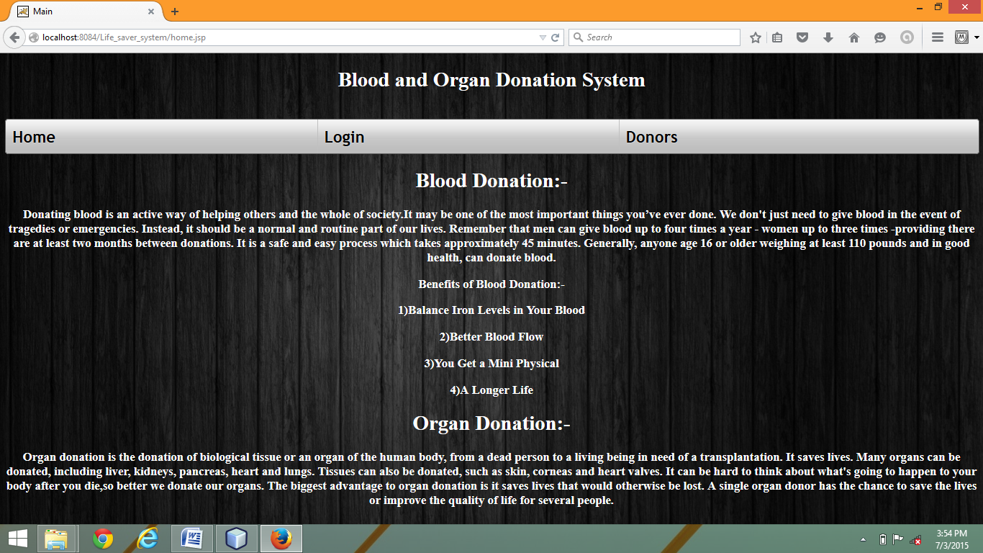

36

**LOGIN PAGE FOR ADMIN, DOCTORS AND DONORS:-**

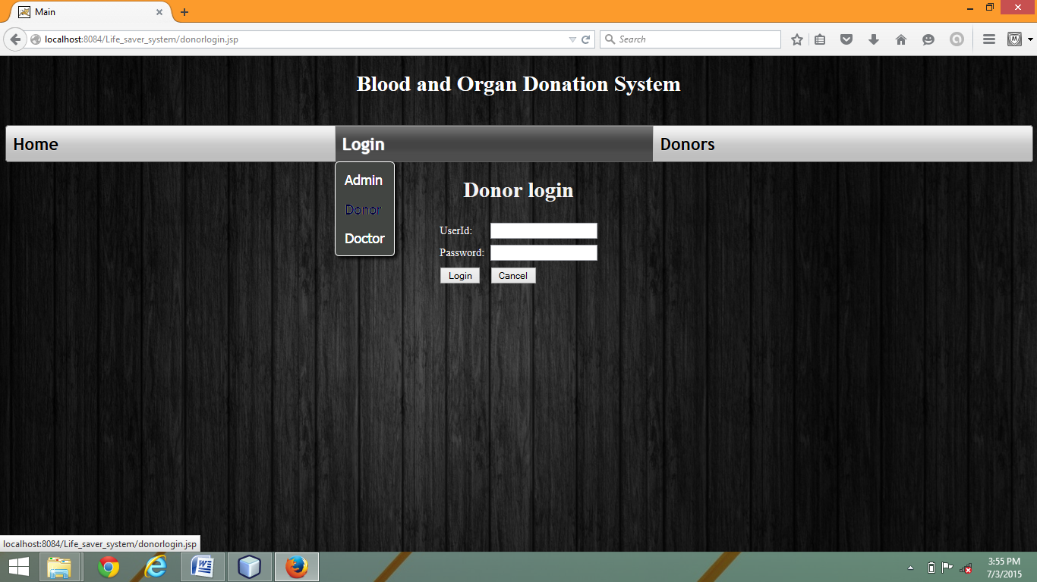

37

**DONOR’S REGISTRATION PAGE:-**

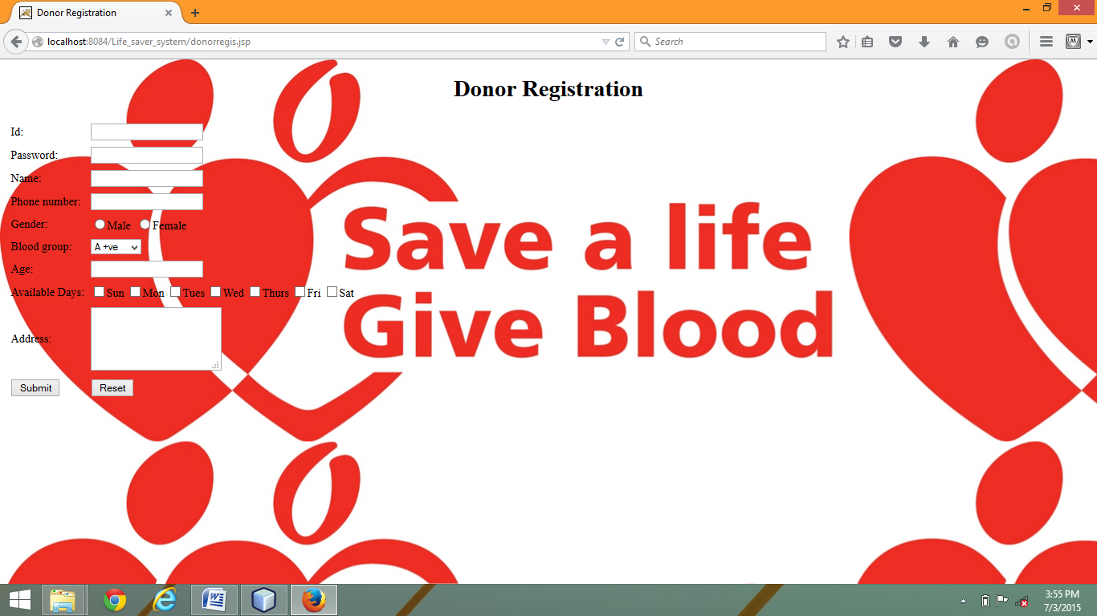

38

**DOCTOR’S REGISTRATION PAGE:-**

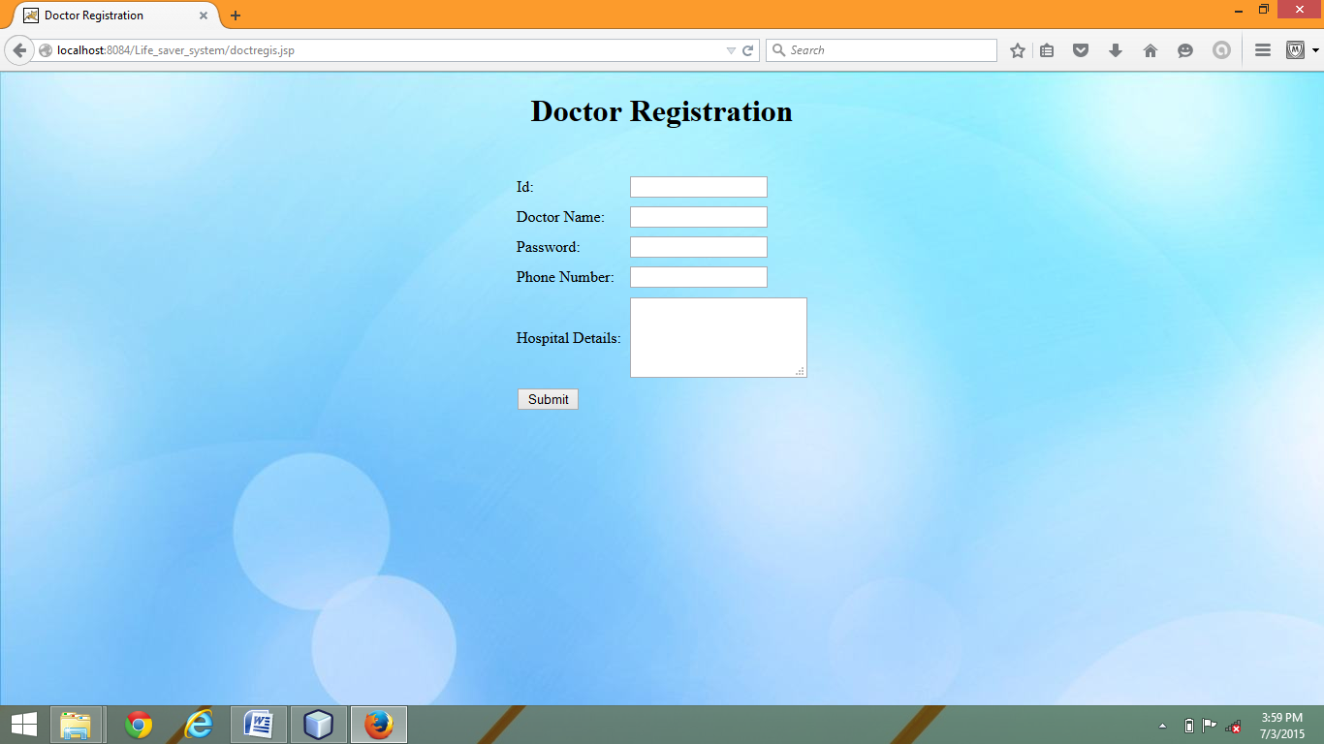

39

**ADMIN PAGES AFTER LOGGING IN:-**

**ADMIN HOME PAGE:**

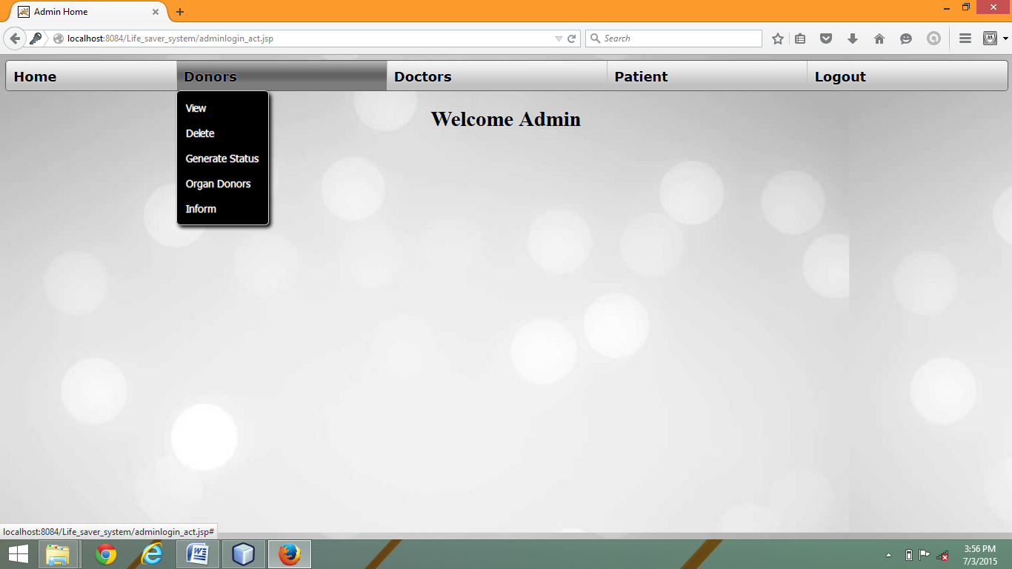

40

**ADMIN VIEWING DONOR’S LIST:-**

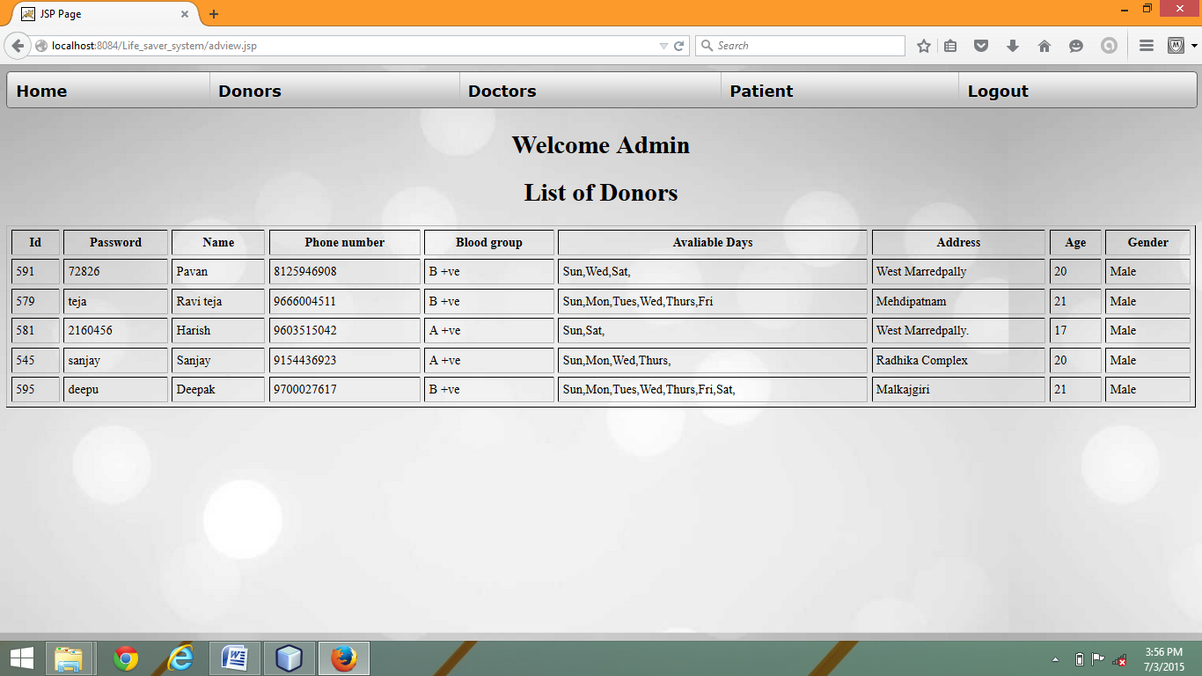

41

**ADMIN VIEWING DOCTOR’S LIST:-**

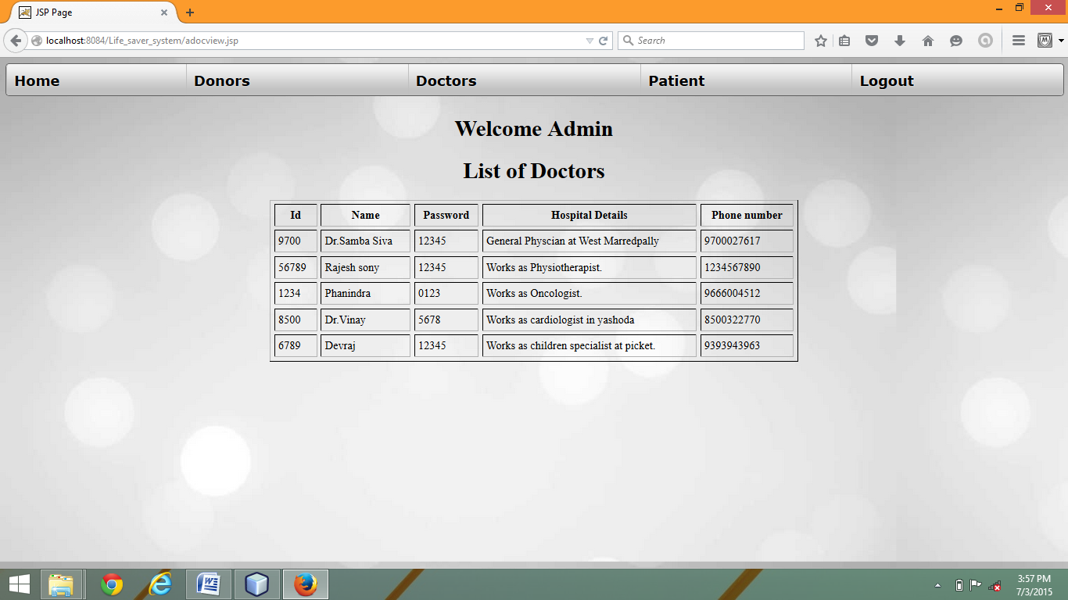

42

**ADMIN VIEWING PATIENT’S LIST:-**

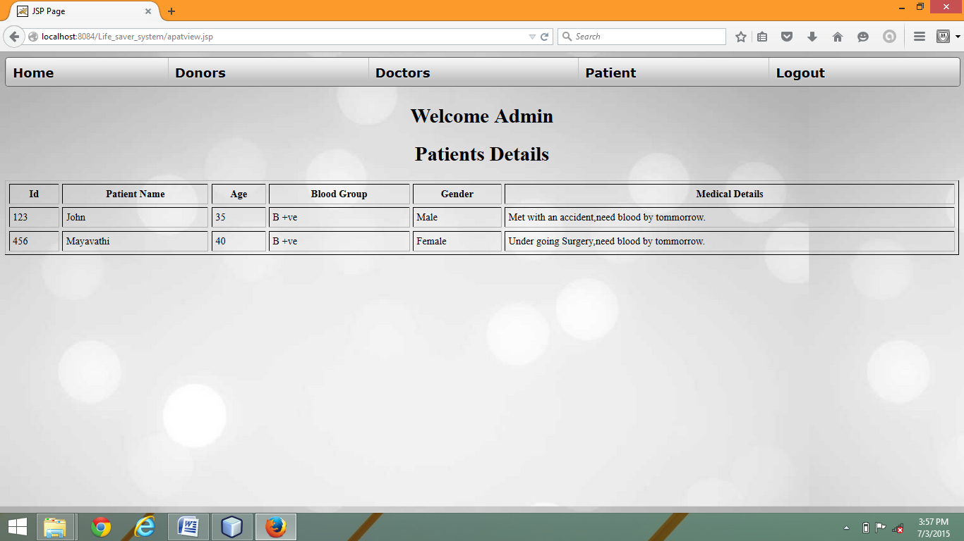

43

**DONOR’S PAGES AFTER LOGGING IN:-**

**DONOR’S HOMEPAGE:-**

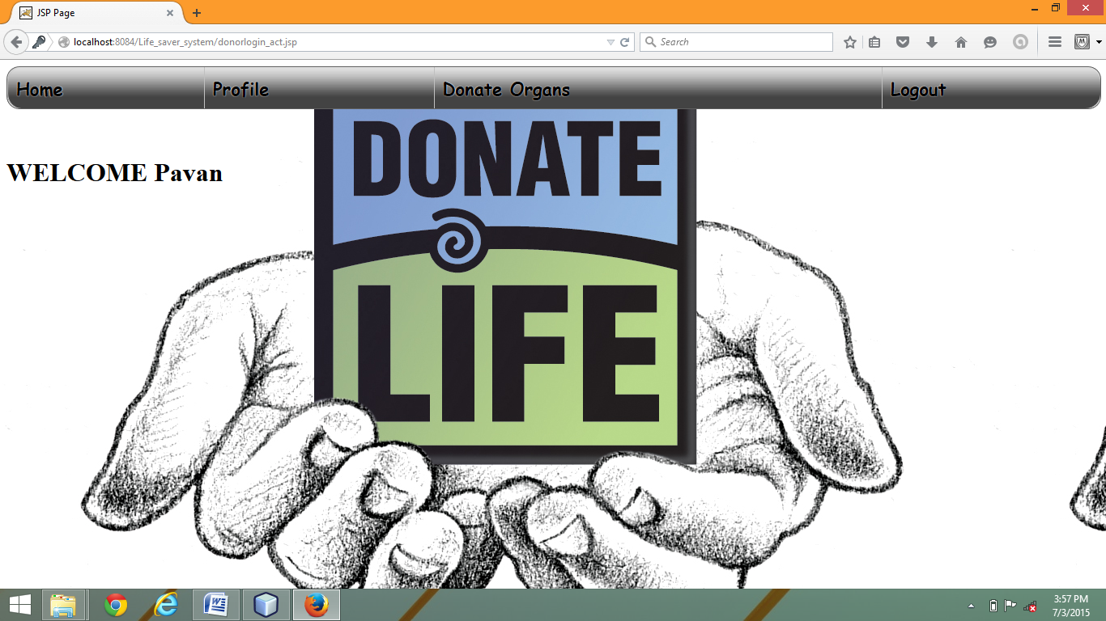

44

**DONOR REGISTRATION AS ORGAN DONOR:-**

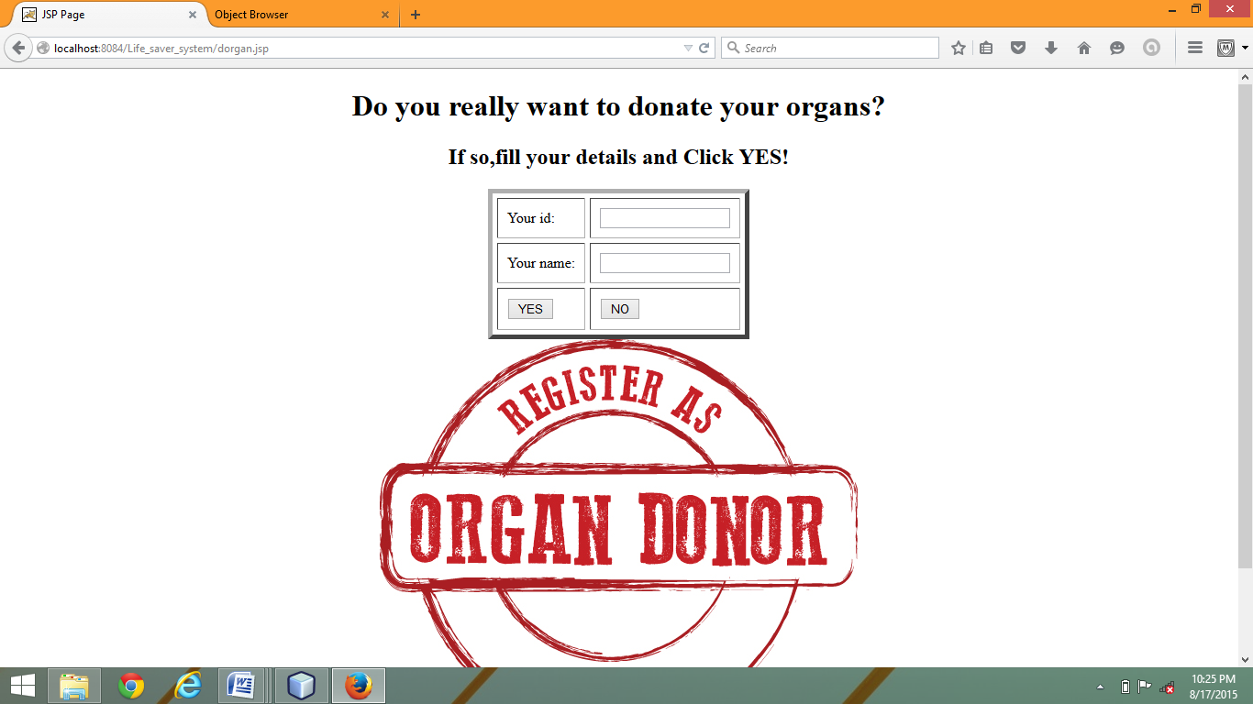

45

**DOCTOR’S PAGES AFTER LOGGING IN:-**

**DOCTOR’S HOME PAGE:-**

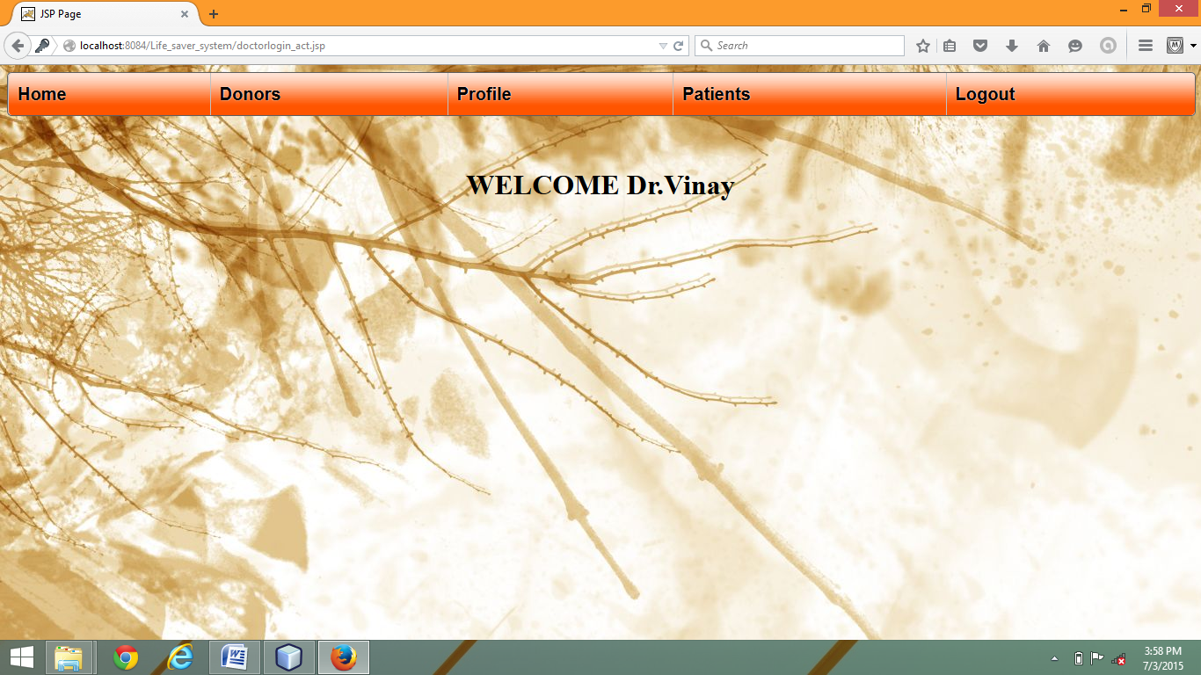

46

**DOCTOR REGISTERING PATIENTS:-**

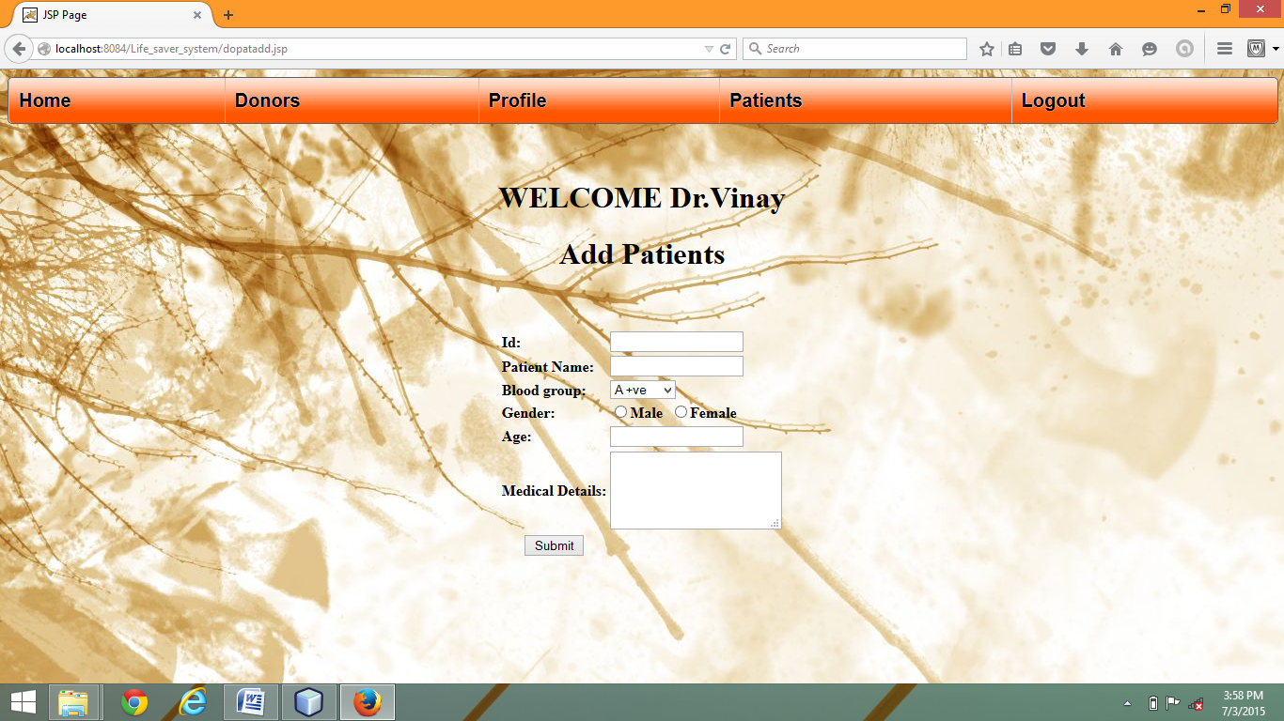

47

**DOCTOR VIEWING PATIENT’S LIST:-**

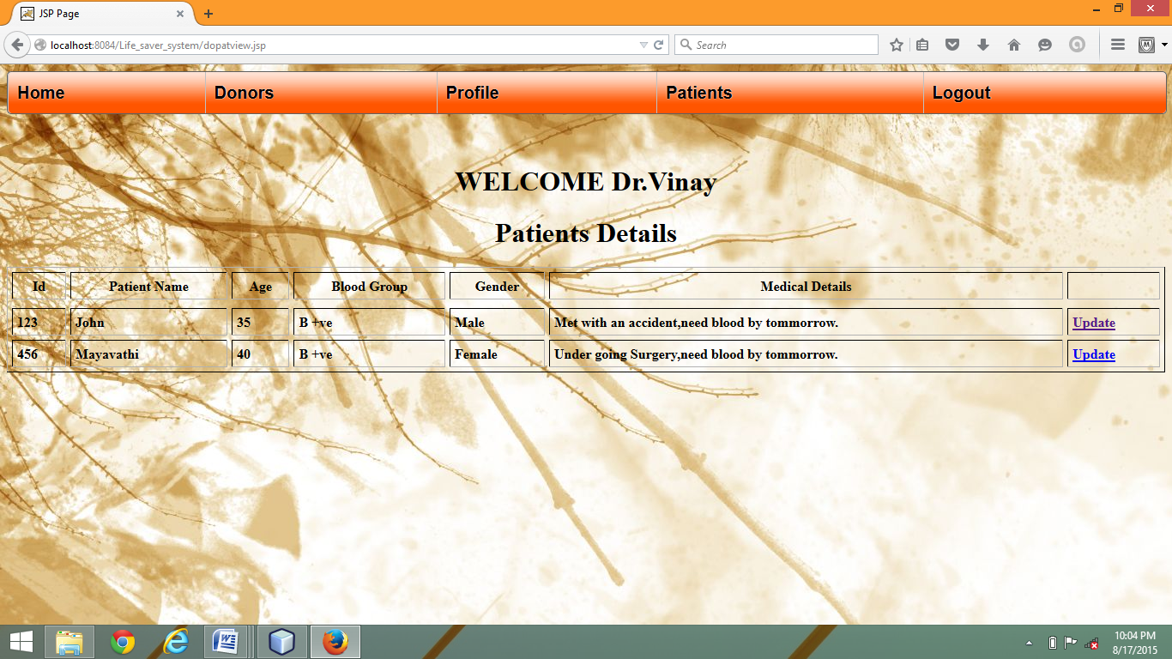

48

**9.BIBLIOGRAPHY:**

**BOOKS:**

Author: Hans Bergsten, Title: Java Server Pages, Publications: O’Reilly.

**WEBSITES:**

www.google.com

www.w3schools.com

49